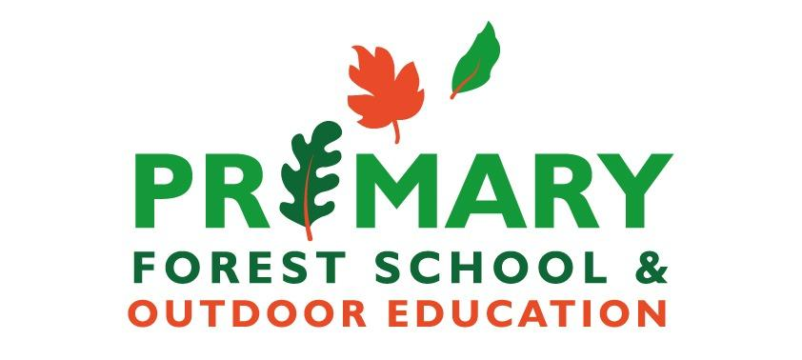
214.03.2024
Burton Bradstock Robins Forest School Weekly Report.

Today was all about having a go with a different Tool: Hammer’s. The class were given a piece of Calico and then drew the First Letter of their name in bubble writing. Then we found some grass and petals to lay on our Calico and we hammered the grass/petals to smash them onto the fabric to create Dye. This is a Japanese technique which means ‘Leaf dye’ ‘Happa Zome’. They are drying at school as the petals/grass will fall off and you will be left with a beautiful print and dye on the fabric.
Each child wore gloves to protect their hands. It was a little tricky as it was quite windy and still very muddy, so the children had to try and hold the calico, and their chosen leaf and then Hammer.
While a small group of 6 were having a go at the ‘Happa Zome’ the other children in the class were exploring the site. Playing in the mud, Building amazing bug/mini beast habitats and playing with the plastic bugs too were all activities the children enjoyed.
We had to return to school as it did rain and then continued to.
We had to think of an animal that began with our name letter e.g. Jenson Jumping Jaguar. This is all about Alliteration and Adjectives.
After changing our clothes and washing our hands we returned to class for a quiet moment to think about our bodies and how hard they work. It was good to have a moment to think and stop in our busy day.
We finished by getting out the ropes and talking about our next session which will be dens. We had a go at making a Reef knot (Pretzel knot). I have included an image in case your child would like to have a go and practice. It would also be good to think about if your child knows their Left from their Right.


